On the old host computer

Go into the services and stop the service ‘Adaptive Server Anywhere – OC_NETWORK’ *note* this will kick everyone out of using optimum control out
On the service ‘Adaptive Server Anywhere – OC_NETWORK’ you will need to right click and go into properties, under the start up type drop down select disabled
Go into C:\OptimumData there should be a file called ocdata.db transfer that over to the new machine

On the new machine
Install this https://tracrite.blob.core.windows.net/installers/network/ocnetwork7.exe
Replace the ocdata file from C:\OptimumData with the one from the old computer
Go into services and start ‘Adaptive Server Anywhere – OC_NETWORK’
You may need to make a windows firewall exception for C:\Program Files\Sybase\SQL Anywhere 7\win32\dbsrv7.exe

On the workstations
Go into the 32 bit ODBCs
64Bit operating system C:\Windows\SysWOW64\odbcad32.exe
Or
32Bit operating system C:\Windows\System32\odbcad32.exe
Click on the System DSN tab
Highlight oc_network (if you don’t see oc_network update ocdata) and click configure
In the network tab update the ip address to the new server
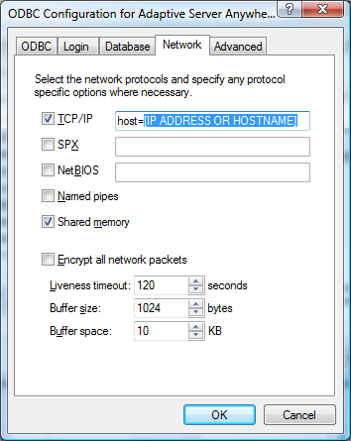
Click ok
You should be able to sign in to Optimum Control

