Configuring an Optimum Control Premier Client
Contents
Configuring an Optimum Control Premier Client 1
Installing the Optimum Control Premier Client 2
Modifying the OCDATA System DSN 3
Editing the OCONTROL.INI File 6

Installing the Optimum Control Premier Client
- Download the setup file for the latest version of Optimum Control Premier from http://www.restaurantvision.com/installs.htm
- Install Optimum Control Premier using the default settings presented in the installation wizard.
- Open the C:\Tracrite folder and locate the ocdata.db file.
- Delete the ocdata.db file.

Modifying the OCDATA System DSN
- Press the start button on your task bar and type odbcad32 into the search field. Press enter to launch the ODBC administrator utility.
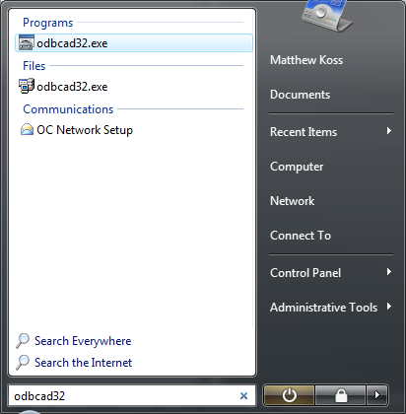
- Select the System DSN tab in the dialog that appears, select the ocdata DSN and click the Configure… button.
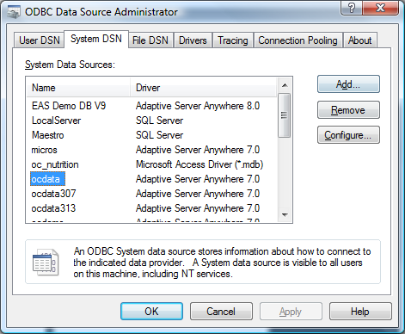
- Change Data source name to match the database service it will connect to. (default: oc_network)
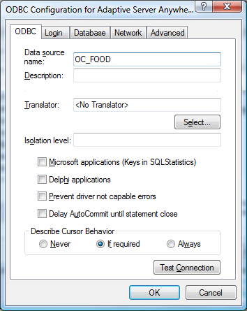
oc_network

- Select the Database tab, enter the name of the database service that the DSN is connecting to, and uncheck the Automatically shut down database after last disconnect checkbox. Blank out all of the remaining fields.
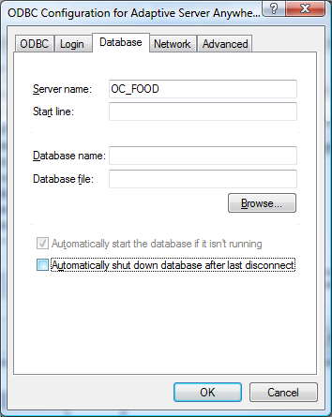
oc_network
- Select the Network tab and check off the TCP/IP check box. Alternatively, a host name may be entered in the text box beside the TCP/IP checkbox. This may be needed if multiple databases are being installed or the client is connecting in a WAN environment but is not always required.
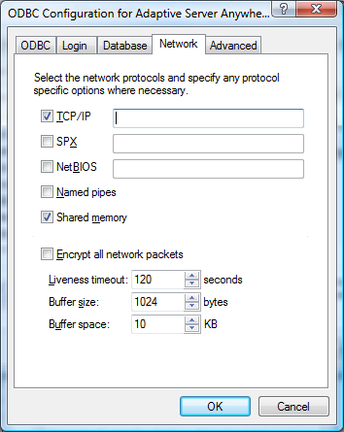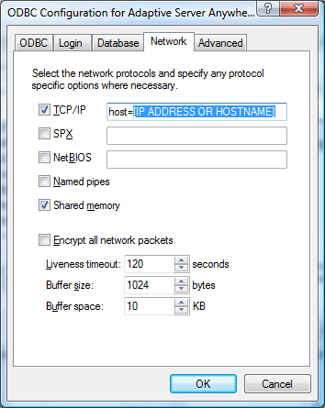
- Return to the ODBC tab and click the Test Connection button to ensure the settings entered are correct.

Editing the OCONTROL.INI File
- Open explorer and navigate to C:\Tracrite.
- Open ocontrol.ini in Notepad.
- Press CTRL + H to open the Replace dialog.
- Type ocdata in the Find what field and type the name of the DSN (which was created in step 4 in the Creating a New System DSN section above) in the Replace with field. Click Replace All then save the changes to the document and close Notepad.
oc_network

