Configuring an Optimum Control Premier Client
Contents
Configuring an Optimum Control Premier Client 1
Installing the Optimum Control Premier Client 2
Modifying the OCDATA System DSN 3
Editing the OCONTROL.INI File 6

Installing the Optimum Control Premier Client
- Download the setup file for the latest version of Optimum Control Premier from
- Install Optimum Control Premier using the default settings presented in the installation wizard, It will ask for the host computer ip address, enter that information.

Modifying the OCDATA System DSN
- Press the start button on your task bar and type odbcad32 into the search field. Press enter to launch the ODBC administrator utility.
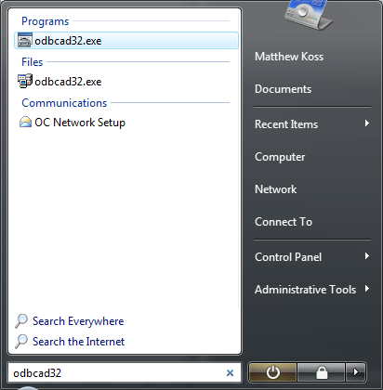
- Select the System DSN tab in the dialog that appears, select the ocdata16 DSN and click the Configure… button.
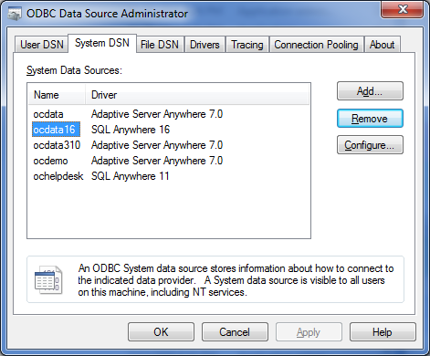
- Change Data source name to match the database service it will connect to. (default: oc_network)
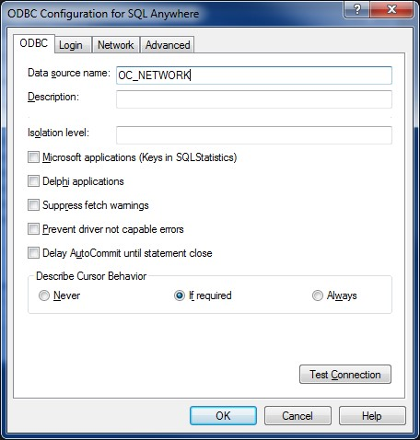

- Select the Login tab, Change Action to “Connect to a running database on another computer. Host will be the IP address of the computer that is hosting the database or the computer name.
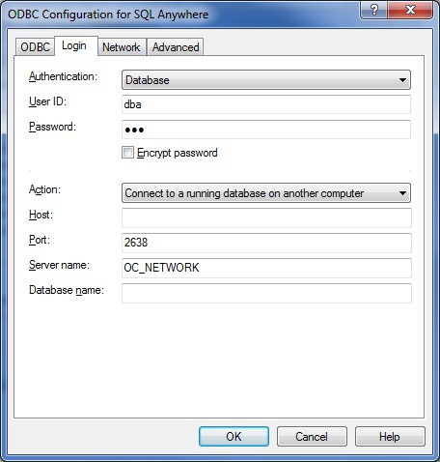
- Return to the ODBC tab and click the Test Connection button to ensure the settings entered are correct.

Editing the OCONTROL.INI File
- Open explorer and navigate to C:\Tracrite.
- Open ocontrol.ini in Notepad.
- Press CTRL + H to open the Replace dialog.
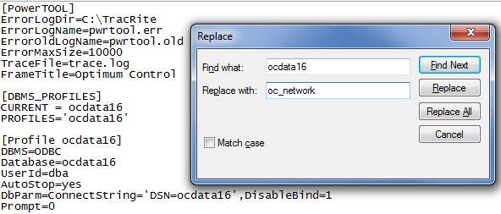
- Type ocdata16 in the Find what field and type the name of the DSN (which was created in step 4 in the Creating a New System DSN section above) in the Replace with field. Click Replace All then save the changes to the document and close Notepad.

